For Immediate Release
Oct 11, 2023

GOED Releases Two Market Research Reports: Annual Global Omega-3 Ingredient Market Report and First-of-Its-Kind Consumer Search Trends Report
The Global Organization for EPA and DHA Omega-3s (GOED) has published two important reports detailing trends in the global EPA and DHA omega-3 industry.
Global EPA and DHA Omega-3 Ingredient Market Report
The 2023 edition of GOED’s annual Global EPA and DHA Omega-3 Ingredient Market Report is now available. The report details the entire EPA and DHA omega-3 industry in the raw materials segment of the supply chain, which was a 121,940 metric tons (mT) market in 2022. Volume increased 3.8% last year, while the value of omega-3 ingredients increased 7.9%, to US$1.69 billion.
This year’s report includes market figures for 14 omega-3 sources in 11 geographies and six end product applications (dietary supplements, pharmaceuticals, infant formula, food and beverage, pet food and clinical nutrition) as well as dashboard “at a glance” charts for each section, a set of PowerPoint slides containing key market figures and the raw data in Excel form with a built-in forecast generator.
Because of GOED’s intimate knowledge of the category and its access to proprietary sales data from member companies, the report is considered the most accurate and comprehensive report available on the global EPA and DHA industry. A sample of the report, as well as purchase information, is available on the GOED website.
Gauging Global Consumer Interest in EPA and DHA Omega-3s
GOED also published a first-of-its-kind report analyzing consumer internet search trends related to EPA+DHA omega-3 topics in order to better understand the top questions, attitudes and perceptions of global consumers. The report details global, continental and national search trends and includes annual data as well as trends over the past 10+ years. Included in the details are what search terms — “omega-3s,” “fish oil,” “algae oil,” “DHA” etc. — are most commonly searched from one country to another, and how media stories impact search volume.
Global search interest in omega-3s has grown more than 50% after a period of flat interest from 2004-2009.
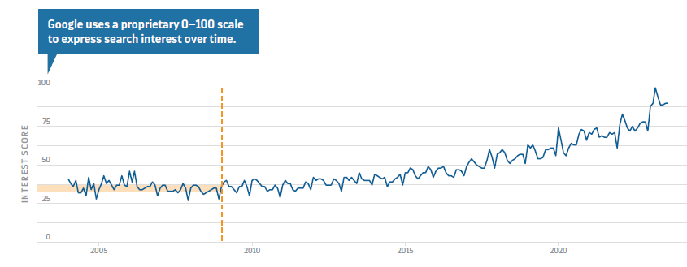
The report is now available for purchase on GOED’s website.

About GOED: GOED (Global Organization for EPA and DHA Omega-3s) represents the worldwide EPA and DHA omega-3 industry, with a mission to increase consumption of EPA and DHA omega-3s around the world. The membership is built on a quality standard unparalleled in the market and members must comply with quality and ethics guidelines that ensure members produce quality products that consumers can trust. Our 180+ members represent the entire supply chain of EPA and DHA omega-3s, from fisheries and crude oil suppliers to refiners, concentrators and finished product brands.

Media Inquiries:

Vicky Lin, Communications Manager
Email: vicky@goedomega3.com
Phone: +1 519-760-8921

